THE PPE KIDS FACILITY DESIGN STANDARD

Hard-Coding Environmental Transparency, Access Control, and Visual Integrity
This document compiles the complete, actionable physical specifications and architectural mandates that comprise the official PPE Kids Facility Design Standard as referenced across our organizational security frameworks.
Administrative rules tell personnel how to behave; physical design makes it structurally impossible to behave otherwise. The overriding objective of this standard is to systematically eliminate structural isolation, ensuring that every child-occupied area is entirely visible, interruptible, and reportable.

1. Visual Transparency & Line-of-Sight Requirements
Abuse relies entirely on physical isolation to cross behavioral boundaries without fear of interruption. This standard hard-codes visual clarity into all programming environments to permanently disrupt grooming loops and opportunistic boundary testing.

The Vision Panel Mandate
- Eye-Level Glass Retrofits: Safety-glass vision panels must be installed in every single interior door throughout the facility.
- Mandatory Placement: Any room where youth programming, childcare, mentoring, counseling, or music lessons occur must feature a clear window embedded directly into the door frame at adult eye level.
- Approved Materials: Traditional opaque wood, frosted privacy panels, and solid metal doors must be completely replaced with tempered safety glass or shatterproof transparent paneling.
- Usage Restriction: If a room cannot be structurally retrofitted with a transparent vision panel, it is legally and operationally barred from hosting youth activities.

The Half-Door Rule (Early Childhood Layouts)
- Dutch Door Integration: All nurseries, toddler rooms, and early childhood daycare spaces must integrate half-doors or Dutch doors into their entryways.
- Operational Configuration: The bottom half of the door must remain latched to maintain physical containment of the children, while the top half must remain completely open during all operational hours.
- Corridor Connection: This configuration keeps early childhood environments acoustically and visually connected to the main hallway, creating a continuous, unintercepted corridor sightline for passing supervisors and hall monitors.

The Absolute Rule of Open Blinds
- Unobstructed Windows: All interior window blinds, curtains, and decorative door coverings must remain completely open during all active programming hours.
- Compliance Violations: Covering or blocking a door window or interior vision panel with posters, student artwork, or structural clutter is designated an immediate compliance infraction.
- Casual Observation: Every programming space must remain permanently open to casual, passing observation from the exterior corridor.

Transparent Fronts for Staff Offices
- Drywall Elimination: All solid drywall office fronts belonging to youth leaders, school counselors, administrators, or educators placed directly adjacent to youth activity zones must be replaced with transparent glass paneling.
- Auditory vs. Visual Privacy: This standard allows a professional to conduct a quiet, confidential conversation with a student to protect their auditory privacy, while ensuring their physical actions remain completely visible to anyone walking down the main hallway.
- High Interruptibility: Hard-coding transparent office fronts creates structural interruptibility—the certainty that any inappropriate physical behavior will be instantly noticed and disrupted by peers.

2. Illumination and Corridor Safety Standards
Perpetrators and peer-on-peer offenders exploit poor lighting, heavy architectural shadows, and complex corridor layouts to secure transient visual cover during high-chaos transition windows.

Shadow-Free Illumination Upgrades
- Fixture Audits: Facility managers must audit and upgrade all lighting fixtures across corridors, common areas, entrance vestibules, and stairwells.
- LED Transition: Low-wattage aesthetic lighting must be systematically removed and replaced with high-output commercial LED fixtures.
- Visual Pockets: Hallway lighting must be bright, consistent, and completely free of structural shadows, dim pockets, or low-accountability recesses where an individual might attempt to isolate a child.

Tactical Convex Mirrors
- Blind Spot Mitigation: Where older facility architectures feature "dead-end" hallways, L-shaped corridors, or sharp, blind intersecting junctions, structural remediation is mandatory.
- Strategic Mirror Placement: Industrial convex mirrors must be strategically installed at every blind intersection and hallway corner where walls cannot be demolished.
- Sightline Extension: These mirrors instantly extend an observer's line of sight around structural bends, allowing a single floor monitor or passing adult to scan multiple hallways simultaneously and eliminate hidden corners entirely.

3. Perimeter Gateways and Access Control Architectures
Access control serves as the structural grid that regulates who enters the facility's light and restricts the unmonitored drift of insiders, visitors, and youth into auxiliary spaces.

Physical Perimeter Verification Gateways
- Single Point of Entry: All human movement into the facility must be funneled through a single, heavily fortified point of entry known as the Physical Perimeter Verification Gateway.
- Secure Entry Vestibules (The "Mantra Trap"): Main entrances must utilize a double-door secure vestibule configuration. The exterior door remains unlocked during business hours, but the interior door remains electronically locked.
- Reception Clearance: Visitors are funneled into this secure holding zone, where they must be visually and electronically cleared by a staffed reception desk before being buzzed into the main child-programming areas.
- Electronic Traffic Systems: All children, parents, and volunteers must utilize a formal electronic check-in and check-out system. Parents receive matching security tags that must be physically or digitally verified by staff before a child is released to eliminate chaotic pickup windows.

Facility Zoning & Auxiliary Space Lockdowns
- Card-Access Segmentation: Facilities must utilize restricted-access keycards, electronic fobs, or heavy commercial-grade locks to divide the facility into clear, operational sectors.
- Isolation of Youth Zones: Child-occupied areas must be completely segmented and isolated from utility, storage, and administrative spaces.
- The Lockdown Checklist:
- Supply and Mechanical Rooms: Janitorial closets, supply rooms, and electrical hubs must remain mechanically locked at all times and are strictly off-limits to children and youth.
- Unused Programming Wings: Empty classrooms, basements, or secondary chapels not actively hosting a fully staffed program must remain locked down to prevent opportunistic actors or peers from slipping away into empty rooms.
- Single-Occupancy Staff Zones: Staff breakrooms, private executive offices, and administrative workspaces must require keycard access to prevent unauthorized minors from entering unmonitored adult zones.

4. High-Risk Restroom & Changing Area Design
Restrooms and changing areas represent the ultimate challenge in safety engineering because the absolute requirement for user privacy directly collides with the requirement for visibility and oversight. They are documented core hot spots for opportunistic abuse, high-density daycare victimization, and peer-on-peer sexual abuse (COCSA).
- Single-Occupancy Priority: The PPE Kids facility design standard explicitly prioritizes single-occupancy, unisex restroom configurations over traditional multi-stall architectures for youth-adjacent spaces.
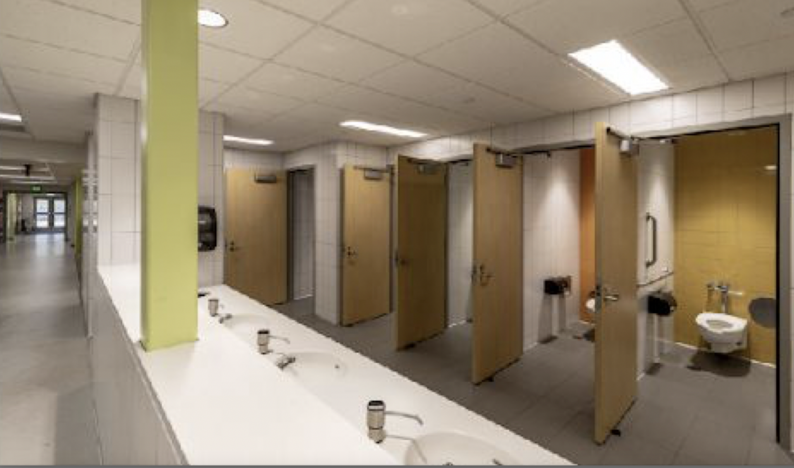
- Eliminating Proximity Risks: A single-occupancy layout ensures that only one individual uses the restroom at a time, completely removing the physical proximity factor that peer and opportunistic offenders rely on to cross boundaries behind a locked stall door.
- Open-Sightline Approaches: Where restrooms open into main corridors, the entryway must utilize a standard doorless, maze-like configuration. This configuration blocks direct visual access to the toilet or urinal areas from the hallway but allows passing staff and hall monitors to easily hear acoustic cues and monitor exactly who enters and exits the space.
- Visible Common Placement: Restrooms used by children must be placed in highly visible, heavily trafficked common areas—never tucked away down isolated, quiet auxiliary wings.
- Systemic Remediation Overhauls: Following any facility walk-through or identified peer-on-peer boundary violation, existing multi-stall wings must be systematically transitioned into single-occupancy restroom configurations with an open-sightline hallway approach.

5. Visibility Retrofit & Implementation Matrix
To prevent analysis paralysis when executing facility overhauls, updates are organized into a strict, time-phased priority grid to balance cost, ease of execution, and safety impact:
Priority Level | Structural Action  Required | Safety Impact &  Rationale | Cost &  Implementation
Priority 1:  Immediate  Visibility | Install safety-glass  windows to interior  doors; mandate  permanently open  window blinds. | Establishes instant  physical visibility; strips internal threats of  immediate  concealment  options. | Cost: Low to Medium  Ease: High
Priority 2:  Operational  Guardrails | Enforce the strict  Two-Adult Rule;  standardize visitor  badges and  mandatory escorts. | Shuts down  unmonitored,  One-on-one  adult-to-child  situations using  human guardrails. | Cost: Near Zero  Ease: High
Priority 3:  Lighting &  Corridors | Upgrade fixtures to  shadow-free LED  lighting; install  corner convex mirrors. | Minimizes structural  cover and eliminates shadows in  high-traffic transition hallways. | Cost: Low to Medium  Ease: Medium
Priority 4:  Access  Verification | Implement electronic  check-in  architectures; build secure  vestibules ("mantra traps"). | Controls the physical  perimeter; regulates  traffic flow and  creates  high-accountability  witness points. | Cost: Medium to High  Ease: Capital  Structural  Project
Priority 5:  High-Risk  Zones | Transition to  single-occupancy  restrooms; implement  half-Dutch doors in  early childhood zones. | Safely balances user  privacy with absolute  visual and acoustic  protection in  high-vulnerability  spaces. | Cost: Medium to High  Ease: Capital  Structural  Project

By hard-coding these architectural specifications directly into your physical space, you transform your building into a self-policing protective environment where transparency is guaranteed by design.

